Looking for a trusted escort service in ITC Grand Central Mumbai? Enjoy premium companionship in one of Mumbai’s most luxurious hotel destinations with elegant and discreet company designed around your comfort and privacy. Whether you are visiting for business, planning a private evening or simply looking for quality companionship during your stay, the right company can make your experience feel more relaxed and memorable.
At Isha Bansal, we provide a premium escort service in ITC Grand Central Mumbai with a focus on privacy, professionalism and a smooth booking experience. ITC Grand Central is known for luxury hospitality, beautiful interiors and a peaceful atmosphere, making it an ideal place for private companionship and comfortable meetings in Mumbai.
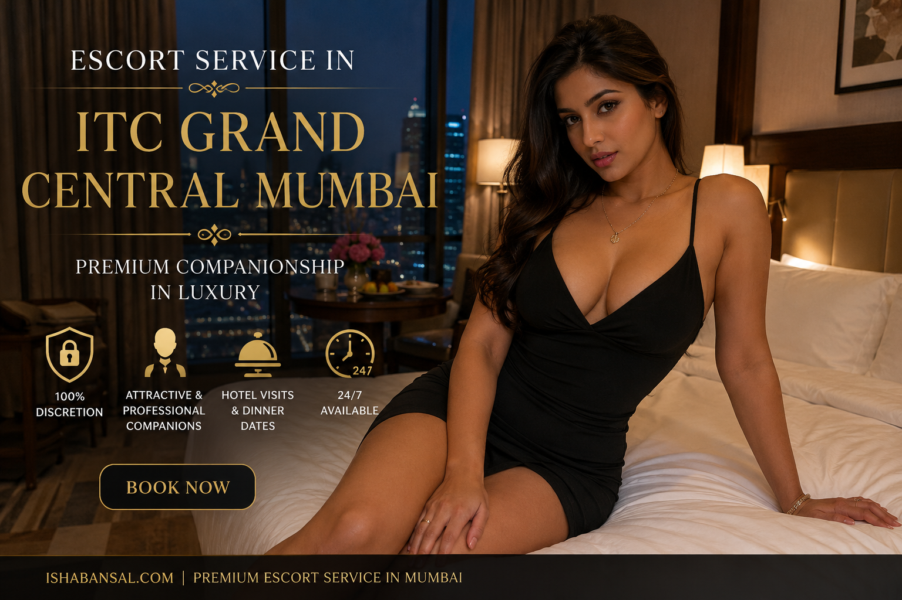
Our companions are confident, stylish and respectful. Many guests choose an escort service in ITC Grand Central Mumbai for dinner dates, hotel stays, business travel or social evenings where they want elegant company in a comfortable setting. The experience is personalized based on your preference so you can enjoy meaningful time with someone warm, presentable and easy to connect with.
Privacy is always important when choosing companionship. That is why every booking is handled carefully with complete discretion and respectful communication. From your first message to final arrangements, the process stays smooth, private and convenient. Clients trust Isha Bansal because we focus on comfort, reliability and creating a premium experience throughout Mumbai’s top hotels.
ITC Grand Central Mumbai offers the perfect blend of comfort and luxury. The premium rooms, refined hospitality and peaceful surroundings make it one of the most preferred destinations for guests who enjoy high standards and a private atmosphere. Choosing an escort service in ITC Grand Central Mumbai adds a personal touch to your visit and helps create a more enjoyable and memorable stay.
Whether you are in Mumbai for a short trip or spending time in the city for business, premium companionship can make your evening feel more relaxed and complete. Some guests enjoy private conversations and quality time after a busy day, while others prefer elegant company for dinner or social plans. Every experience is handled with care and personalized attention.
At Isha Bansal, we understand that clients value trust, comfort and privacy. Our escort service in ITC Grand Central Mumbai is created for guests who appreciate respectful companionship and a professional approach. We focus on making every meeting smooth and comfortable so you can enjoy your time without stress.
If you are searching for a premium escort service in ITC Grand Central Mumbai, Isha Bansal offers elegant and discreet companionship with a trusted personalized experience in Mumbai. Enjoy luxury surroundings, respectful company and memorable private time with complete privacy and convenience during your stay.

